**Maroun Semaan Faculty of Engineering and Architecture**

**American University of Beirut**



**Quality Assurance Report**



**AI-Powered Career Advisor**

# Quality Assurance Report for Machine Learning Project

## 1. Project Overview

**Project Name**: AI-Powered Career Advisor

**Version 1.0.0**

**Team Members**: Mahmoud Chaer, Zakaria Labban, Hadi Elham, Ali Alaaeddine.

**Date**: 12/12/2024

**Objective**: The purpose of this project is to create an integrated platform that empowers users to enhance their career development through personalized recommendations. It provides tools for skill gap analysis, resume building, and career path visualization, leveraging APIs to fetch relevant job listings, courses, and projects. By combining automation, real-time chatbot interaction, and secure data handling, the project aims to simplify career planning and support users in achieving their professional goals effectively.2. Project Components

### 2.1 Core Applications

**Career Advisor App**

**Purpose**: The Career Advisor App provides tailored career recommendations by analyzing user profiles and resumes. It suggests jobs, courses, and projects to help users advance in their careers and bridge skill gaps. The app leverages APIs (Adzuna, Coursera, GitHub) for real-time opportunities and facilitates continuous improvement through user feedback​.

**Chatbot App**

**Purpose:** The Chatbot App offers real-time career advice, leveraging user profile data for personalized responses. It answers career-related questions, provides suggestions, and interacts naturally to guide users through their career planning process​.

**CV Builder App**

**Purpose**: The CV Builder App allows users to create professional resumes quickly. It collects user information, including skills, education, and experiences, and generates a polished CV in a downloadable format. The app streamlines the resume creation process while ensuring all critical details are included​.

**Career Path Visualization**

**Purpose**: The Career Path Visualization tool helps users map out their career progression interactively. It connects job roles, courses, and projects into a coherent graph, enabling users to understand the skills and experiences required for their desired career trajectory​.

**Skill Gap Analysis App:**

**Purpose**: The Skill Gap Analysis App evaluates the user's technical and soft skills against their career goals. It identifies areas for improvement, visualizes skill levels using radar and bar charts, and provides actionable insights to enhance competencies and achieve career milestones​.

**Ideal Job Finder App**  
**Purpose:** The Ideal Job Finder App empowers users to discover their perfect career opportunities by leveraging their unique skill sets. It collects user-inputted soft and technical skills, processes them using advanced embeddings from OpenAI, and matches them with job categories stored in a PGVector database. The app uses similarity scores to identify the top three distinct matches for the user, ensuring the results are tailored to their capabilities. This robust combination of user-provided data and AI-powered analysis makes the app highly accurate in aligning users' skills with relevant job opportunities.

### 2.2 Utility Scripts

### File Utilities (file_utils.py)

**Role**:  
This module extracts text from uploaded documents, including PDF and DOCX formats. It ensures accurate and efficient parsing of content, which is critical for analyzing resumes and feeding the extracted data into other applications​.

### Resume Utilities (resume_utils.py)

**Role**:  
This module analyzes and processes resume data to extract personal information, skills, education, experience, and other critical elements. It also classifies user levels, maps skill proficiencies, and prepares data for use in career analysis and recommendations​.

### CV Utilities (cv_utils.py)

**Role**:  
This module facilitates the creation of professional, personalized CVs in PDF format. It compiles user-provided data, such as skills, education, and work experience, into a structured and visually appealing document, making it easy to generate resumes tailored to specific roles​.

### Graph Utilities (graph_utils.py)

**Role**:  
This module visualizes career paths by creating interactive network graphs. It maps relationships between job roles, recommended courses, and projects, providing a clear graphical representation of career progression to guide users effectively​.

### 2.3 Data Handling

### API Data (api_data.py)

**Role**:  
This module facilitates interactions with external APIs such as Adzuna, Coursera, and GitHub. It enables searching for relevant job listings, learning courses, and open-source projects, enhancing the user's career recommendations. The module ensures real-time data retrieval and integrates GPT-based filtering to maintain the relevance of results​.

### Profile Data (profile_data.py)

**Role**:  
This module is responsible for extracting and managing user information from resumes. It includes functions for parsing education, experience, languages, awards, and projects. This module plays a critical role in building and maintaining comprehensive user profiles, which serve as the foundation for career guidance and recommendations​

## 3. Functional Testing

### 3.1 Career Advisor

**Input**: 50 different resumes from all backgrounds and levels:  
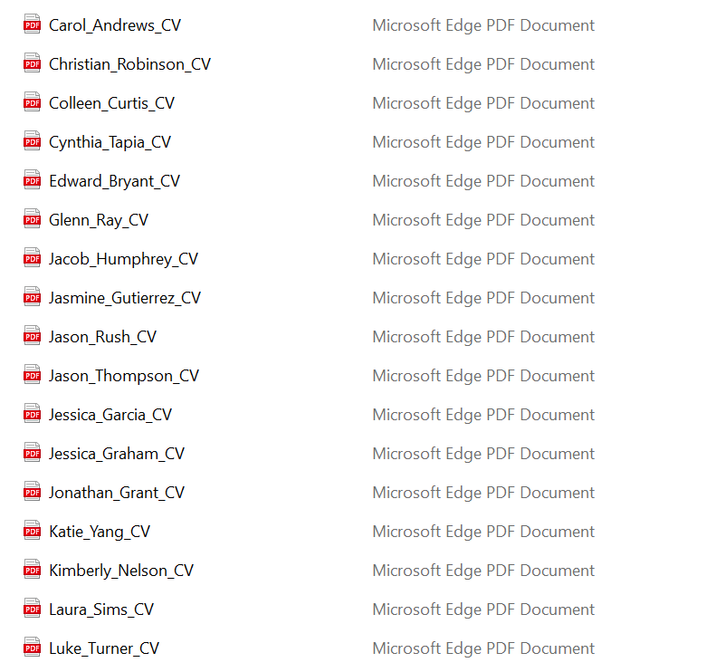

**Output:** Out of the 50 resumes processed, all relevant information was successfully extracted, ensuring that each job listing was accurately aligned with the user’s specified field of work. Additionally, all courses included in the recommendations were verified to be both relevant and accurate in relation to the individual’s professional domain. For GitHub projects, accurate and contextually appropriate projects were identified for resumes in tech-related fields; however, for non-tech-related resumes, the GitHub projects provided were not as aligned with the users' respective fields. Our accuracy metric is defined by the degree to which the output aligns with the user's resume content and specified domain, ensuring high relevance and precision in the results.

### **Advanced Filtering and Feedback Mechanisms**

In the Career Advisor App, we implemented a sophisticated filtering process for job listings sourced from Adzuna to ensure that recommendations are highly relevant to the user's profile. Before presenting a job listing to the user, we pass its title through a GPT-based prompt to assess its relevance to the user's resume. This additional validation step significantly enhances the precision of the recommendations by aligning them with the user's skills, experiences, and career aspirations. Additionally, we incorporated a feedback loop that captures user input regarding their preferences, interests, and dislikes. This feedback is then used to refine the recommendation process, allowing the app to re-run the job generation with these preferences in mind. By dynamically adapting to user feedback, the app ensures a more personalized and satisfactory experience, aligning job recommendations with both the user’s professional profile and their evolving career preferences.

### 3.2 Chatbot:

The chatbot achieves a high level of accuracy because it utilizes advanced GPT-based prompts combined with a deep understanding of the user's background for delivering tailored responses. By leveraging this dual approach, the chatbot ensures that the content aligns precisely with the user’s field of work and interests. The GPT model generates contextually relevant and dynamic outputs, while the integration of user-specific details allows for highly personalized and accurate results. This synergy between the chatbot’s generative capabilities and user-focused adaptability ensures that the answers are not only relevant but also finely tuned to meet the user's needs effectively.

### 3.3 Ideal Job:

The Ideal Job Finder achieves an exceptional level of accuracy by leveraging advanced GPT-based prompts combined with user-specific skills and embedding-based analysis. Out of 50 attempts, we achieved 50/50 relevance in identifying ideal jobs that matched the skills specified in the resumes. Our accuracy metric focused on ensuring that the recommended jobs were directly relevant to the user’s combined technical and soft skills. This approach, powered by OpenAI’s embeddings and similarity searches, guarantees that the results are tailored to the user’s unique capabilities, making the recommendations both precise and reliable.

### 3.4 Skill Gap Analysis:

The Skill Gap Analysis tool maintains high accuracy as it relies on GPT-driven prompts to evaluate user skills against the requirements of specific roles or domains. While GPT enables dynamic and contextually relevant outputs, its performance, though highly effective in most scenarios, may not always achieve perfect alignment. This is because the analysis depends on the precision of user inputs and the comprehensiveness of the role descriptions. Nevertheless, the tool’s robust generative capabilities ensure that skill gaps are identified with considerable accuracy, providing actionable insights for users to bridge their professional development needs.

### 4. Performance Testing

4.1 Time Complexity:  
The Career Advisor App exhibits remarkable efficiency in its performance. The process of finding an ideal job, which involves combining user-provided skills, generating embeddings, and performing similarity searches, requires exactly 1 minute and 30 seconds to complete. This ensures a seamless user experience while maintaining a thorough and accurate recommendation system. All other features of the app, such as skill analysis and presenting recommendations, are executed in near-instant time, showcasing the app's optimization for quick responses and usability.

4.2 Resource Utilization:  
The app is designed with resource efficiency in mind. By leveraging session states to store and retrieve user data, the app minimizes memory usage and avoids redundant computations. This approach ensures a balanced utilization of system resources, particularly memory and CPU, enabling smooth operation even with large datasets or extended user interactions. Additionally, the app's modular design ensures that individual components interact efficiently without overwhelming the system.

4.3 Future Enhancements:  
To further enhance performance, we plan to implement parallel GPT prompt handling. This advanced technique will enable the app to process multiple tasks simultaneously, significantly reducing the time required for complex operations such as embedding generation and similarity analysis. By adopting this parallel processing approach, the app will deliver faster results and accommodate more users without compromising accuracy or resource utilization, reinforcing its capability as a reliable and efficient career advisory tool.

### 5. Code Quality

5.1 Organization**:**  
The Career Advisor App showcases a well-organized codebase, adhering to a clear and logical folder structure that enhances maintainability and scalability. The code is distributed into distinct directories such as .app, .utils and .data each serving a specific purpose. The .app directory contains the core functionality, including the main application logic and user-facing components. The .utils directory is dedicated to helper functions and reusable utilities that simplify repetitive tasks, ensuring a clean separation of concerns. Lastly, the .data directory manages data-related operations such as handling user input, database connections, and processing embeddings. This modular approach not only improves organization but also makes it easy to locate, update, or extend specific parts of the application as needed.

5.2 Readability:  
The code is written with clarity in mind, featuring comprehensive comments and thorough documentation to assist developers in understanding its functionality. Each module is accompanied by descriptive comments explaining the purpose and behavior of functions and classes, ensuring that the code is approachable even for those unfamiliar with the project. The use of consistent naming conventions and adherence to standard coding practices further enhances readability, making the codebase intuitive and easy to navigate.

5.3 Reusability:  
Reusability is a core strength of the app's design, as many components are built to be flexible and adaptable across different features. For instance, utility functions within the .utils directory, such as embedding generation and skill combination processing, are designed to be used across various modules without modification. This reduces redundancy and promotes a DRY (Don't Repeat Yourself) approach. Additionally, the structured use of session states and modular data handling in the .data directory ensures that components can be easily repurposed or extended for future features, reinforcing the app’s scalability and efficiency.

Overall, the well-thought-out organization, clear documentation, and reusable components contribute to the app's high code quality, making it maintainable, extensible, and easy to collaborate on.

Results**:**  
The Career Advisor App delivered excellent results during testing. Out of 50 resumes processed, the app successfully extracted all relevant information and aligned each job recommendation with the user’s specified field of work. Course recommendations were accurate and closely matched the user’s professional domain, and GitHub projects were contextually appropriate for tech-related resumes. However, for non-tech resumes, project recommendations were less aligned with the specific fields. For skill gap analysis, the app reliably identified key areas for improvement, offering actionable insights. Overall, the outputs were highly relevant, demonstrating the app’s capability to align its recommendations with user data effectively.

**Recommendations:**  
To further enhance the app’s performance and utility, several improvements are suggested:

* **Parallel Processing:** Implement parallel GPT prompt handling to reduce processing time and allow multiple tasks to execute simultaneously, enhancing efficiency.
* **Enhanced Project Recommendations:** Expand project matching for non-tech resumes by integrating more diverse datasets and contextual filters.
* **Mobile Integration:** Develop a mobile-friendly version of the app to increase accessibility and usability for on-the-go users.